
4 July 2014 The Weekly Bulletin of Rotary Club of Kathmandu Mid-Town bc-01/7.014
Rotary Club of Kathmandu Mid-Town
Breakfast Chatter


District: 3292 Web: www.rotarymidtown.org.np Club Id: 26776

JULY 2014

Celebrating
25 Years in Rotary


The Rotary Club of Kathmandu Mid-Town, chartered on 8 November 1989, will be celebrating its 25 years of service in November 2014. The celebration will feature success stories, idea exchanges, community service, promote understanding through fellowship, donations for causes and what have you? Any new idea?

Friday, 27 June: The last meeting day of the year 2013-14
President Saroj whose tenure of club presidency was going to end on 30 June 2014 presided at his last weekly meeting. He briefly introduced In-house Speaker Rtn. Frank Meyke, who just completed his term as the Ambassador and would be returning back to his country Germany on 30 June. HE Frank chose to speak on his “Experiences in Nepal”.
President Saroj informed the meeting that Installation Ceremony of Rtn Rabindra Piya as the7th Governor of Rotary International District 3292 scheduled on 1st July at Hotel Hyatt. Club members were encouraged to attend the program.
President Saroj also reminded the club members about the Club’s 25th Installation program scheduled on Friday 11 July at Hotel Soaltee. All were requested to sign the sign-up sheet and attend the program with spouse and friends.
President Saroj shared the information that the Club was successful to receive awards on Membership Retention (100%), Service Award for Polio Free Nepal and 3rd award on Education and Literacy during District Awards program held on 21 June, 014.
President Saroj expressed gratitude to AG Rtn. Pramod, Past Presidents of the Club, 2013-14 Board members and all the Mid-Towners for their kind cooperation and support to complete his tenure as President and expressed good wishes to PE Kul and his team.
PP William proposed official vote of thanks to President Saroj for completing his term as President successfully.

Weekly Meetings and Programs :
Date | Program/Speaker | Program/Topics of Presentation
4 July 2014 | Club members | Members recollecting their happiest moments in Rotary in the past years.
11 Jul 2014 | 25th Installation of the Club | At Hotel Soaltee
18 Jul 2014

Friday, 4 July :
Tour de table - each member will be asked to recount their happiest, most memorable positive moment in their association with Rotary. There will be, of course, time limit of two minutes; members may have many happy moments but make sure only a few are picked up.

What is Rotary?
Rotary International is a volunteer organization of business and professional leaders who provide humani-tarian service, and help to build goodwill and peace in the world. There are approximately 1.2 million Rotary club members belonging to 33,000 Rotary clubs in more than 200 countries and geographical areas.
Founded in Chicago in 1905, Rotary celebrated 100 years of service in 2005. The Rotary Foundation has awarded more than US$2.1 billion in grants, which are administered at the local level by Rotary clubs.
Rotary clubs exist to improve communities through a range of humanitarian, intercultural and educational activities. Clubs advance international understanding by partnering with clubs in other countries. Rotary also encourages high ethical standards in all vocations.
Rotary clubs address critical issues at home and abroad by providing health care and medical supplies, clean water, food, job training, youth development, and education to millions of people in need. Examples of Rotary’s focus areas include:
Polio Eradication - In 1985, Rotary International created PolioPlus – a program to immunize all the world’s children against polio. To date, Rotary has contributed US$800 million and countless volunteer hours to the protection of more than two billion children in 122 countries. Rotary is currently working to raise an addi-tional US$200 million toward a US$355 million challenge grant from the Bill & Melinda Gates Foundation. These efforts are providing much needed polio vaccine, operational support, medical personnel, laboratory equipment and educational materials for health workers and parents. In addition, Rotary has played a major role in decisions by donor governments to contribute over $4 billion to the effort. With its community-based network worldwide, Rotary is the volunteer arm of the global partnership dedicated to eradicating polio. Rotary volunteers assist in vaccine delivery, social mobilization and logistical help in cooperation with the national health ministries, the World Health Organization (WHO), UNICEF, and the U.S. Centers for Disease Control and Prevention.
Peace - In an effort to educate tomorrow’s peacemakers and ambassadors, up to 110 Rotary World Peace Fellows are sponsored each year to study at one of the eight universities for International Studies in peace and conflict resolution. Since 2002, 339 fellows from over 75 countries have participated at a cost of more than $23 million.
International Education - Rotary is the world’s largest privately-funded source of international scholarships. Each year, about 1,000 university students receive Rotary scholarships to study abroad. Rotary clubs also coordinate a high school-age student exchange program that has sent nearly 8,000 students abroad for three months to a year.
Humanitarian Projects - Rotary clubs initiate thousands of humanitarian service projects every year. These volunteer-driven projects address the root causes of conflict, such as hunger, poverty, disease and illiteracy.
Literacy - Rotary clubs work to improve literacy rates worldwide. A unique, Rotary-pioneered approach called the Concentrated Language Encounter (CLE) has proven very effective in resource-strapped develop-ing countries. It was so successful in Thailand, that the Thai government adopted the program nationwide.
Water Management - Recognizing the importance of clean water, many Rotary clubs help to install wells and develop water treatment and distribution systems to increase access to fresh drinking water for communi-ties in need, especially in developing countries.
Source: Rotary International

On Lighter Side :
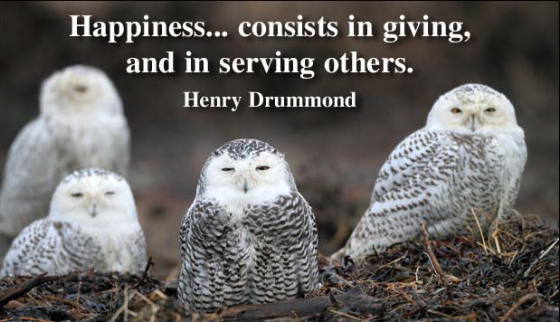

Confucius said “It is better to light a single candle than to sit and curse the darkness." I
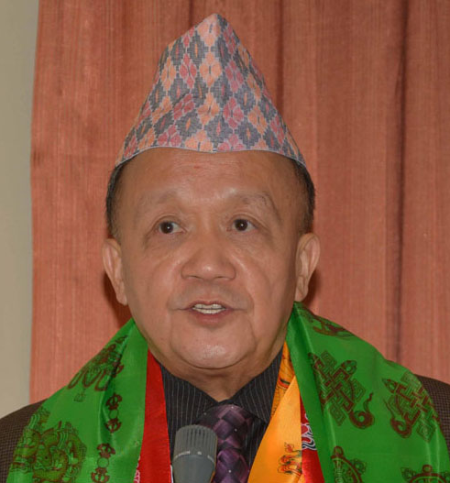
think that one line sums up the way we in Rotary approach the problems of the world.
There is so much difficulty. There are so many people who need help. Many people look
at this and say, ‘There is nothing I can do.’ So they do nothing – and nothing changes.
But this is not the Rotary way. The Rotary way is to light a candle. I light one candle, you
light one candle – and so do 1.2 million other Rotarians. Together, we can do so much
more than we could ever do alone. Together, we can light up the world.

RI President GARY C.K. HUANG

Please send information on club activities, progress reviews on service projects, relevant photos etc to:
BC Editor: RR Shrestha email: rryesrr@gmail.com

4 July 2014 The Weekly Bulletin of Rotary Club of Kathmandu Mid-Town bc-01/7.014

